Technical Datasheet of WIN-PiHAT-8AO
1. Overview
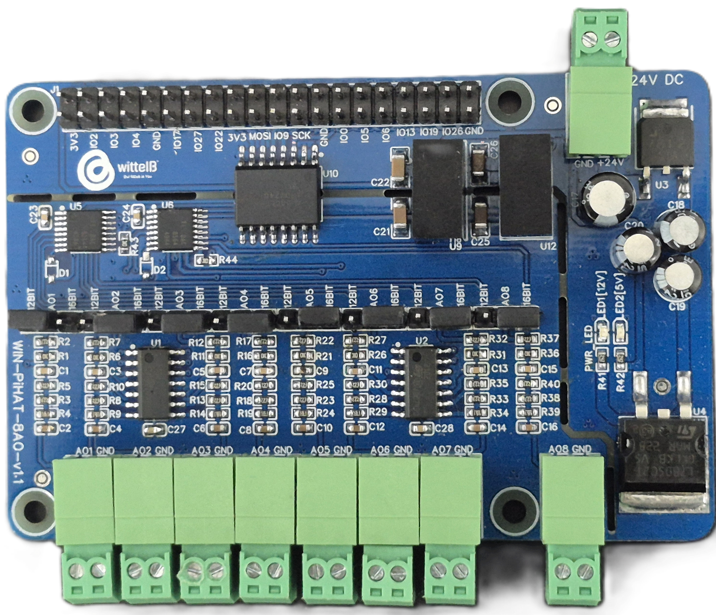
The Analog Output (AO) PiHAT is an 8-channel expansion board for Raspberry Pi 4 and CM4, offering high-resolution analog outputs for industrial control systems. It provides precise signal generation by supporting both 12-bit and 16-bit data resolution, ensuring accurate 0-10V control signals are delivered from the Pi to external analog devices (such as VFDs and proportional valves) for reliable operation in industrial environments.

This PiHAT features a scalable architecture supporting 1 to 8 independent analog outputs (AO). Its population-based design allows channel flexibility while maintaining a compact and reliable solution for embedded control, automation, and precise industrial driving applications.

Specifications
Category | 8AO PiHAT
Output Type | High-Resolution Analog Outputs,  Selectable 12-bit or 16-bit DAC Resolution (0-10V Range)
Channel Count | 8 Channels (Expandable Design Architecture)
Connectors | 2.54 mm Pluggable Terminal Blocks (for sensor inputs),  40-Pin Raspberry Pi GPIO Header

General :–

Dimensions 56 mm L x 85 mm W
Power Input Power – 12/24V DC
Operating Temperature 0 – 60° C (32 ~ 140°F)
Storage Temperature -20 - 70° C (-4 ~ 158°F)
Storage Humidity 5 ~ 95 % RH, non – Condensing
Certifications 

AO (Analog Outputs) :–

Channels 8
DAC Resolution 12-bit / 16-bit (Selectable)
Output Type Single-Ended Voltage Output
Voltage Output Range 0 ~ 10V DC
Max Output Current 35 mA (Short-Circuit limit), ~15 mA continuous
Input Impedance(I) ~ 250 Ω (Typical for mA drop)
Accuracy ±0.1% to ±0.3% FSR (Full Scale Range)
Settling Time 14 µs (Typical)
Protection Short-circuit protection to ground

Configuration :-

All 8 AO channels operate as high-resolution analog outputs and are interfaced to the Raspberry Pi GPIO header through an onboard Digital-to-Analog Converter (DAC) IC. Signal generation is managed via software running on the Raspberry Pi. Each channel is configured to continuously hold and drive outgoing analog signals to external industrial equipment.

When a precise digital value (using either 12-bit or 16-bit resolution) is computed by your software, the Raspberry Pi transmits this data over the SPI communication bus to the DAC. The DAC processes this digital command and immediately converts it into a continuous, proportional analog voltage (0-10V) at the designated output terminal, allowing your software to accurately drive proportional valves, VFDs, and other real-world actuators.

The following are step by step guides for configuration:
- Connect the Module to +12/24V DC POWER SUPPLY.
- Connect the Board to the Raspberry Pi via header pins

Bus Type | Signal Name | Pi GPIO | Header Pin Number | Description
SPI | MOSI | 10 | 19 | SPI data line for TCP112S8 & TCP116S8
 | MISO | 09 | 21
 | SCLK | 11 | 23
 | CE0/CS | 08 | 24
 | CE1/CS` | 07 | 26

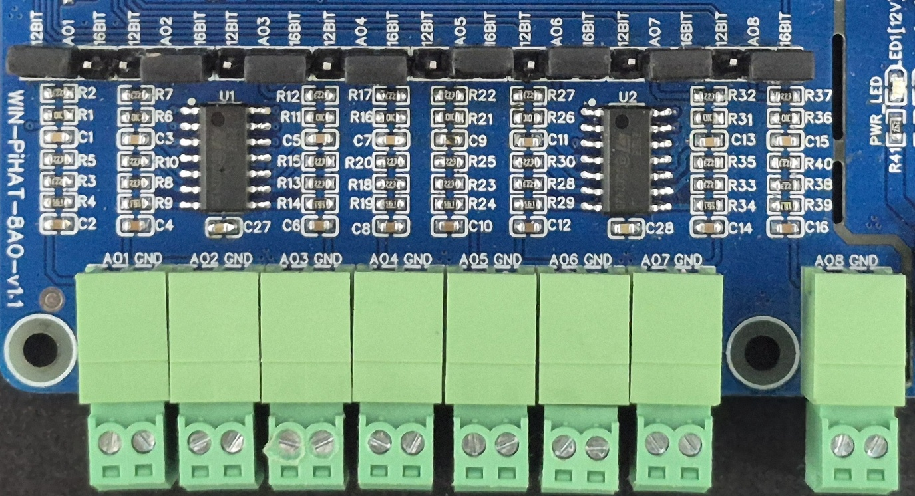
Wiring Diagram:-
AO1-8
GND

- Analog Output (AO) Operation: Each channel provides two terminals: + (Positive) and - (Negative/Common). These are used to deliver generated analog control signals to external devices.
- Channel Configuration (Visual Guide): Each of the AO channels features a dedicated jumper to independently set the bit resolution. The output voltage range is fixed at a maximum of 10V.
  - Resolution Selection: Place the resolution jumper on the 12-bit position for standard control applications, or on the 16-bit position for high-precision signal generation.
- Device Wiring Connections:
  - The receiving device's (e.g., VFD, proportional valve) positive signal input wire should be connected to the + terminal of the desired channel.
  - The device's common or ground reference wire should be connected to the corresponding - terminal.
- Crucial Setup Recommendation: Because the board outputs a fixed 0-10V control signal, always ensure your connected industrial equipment is rated to safely accept up to 10V. Double-check your terminal polarity before sending digital-to-analog (DAC) commands to prevent damage to sensitive receiving inputs.

Sample Test Code: WIN-PiHAT-8AO
Hardware Interface & Connector Layout:
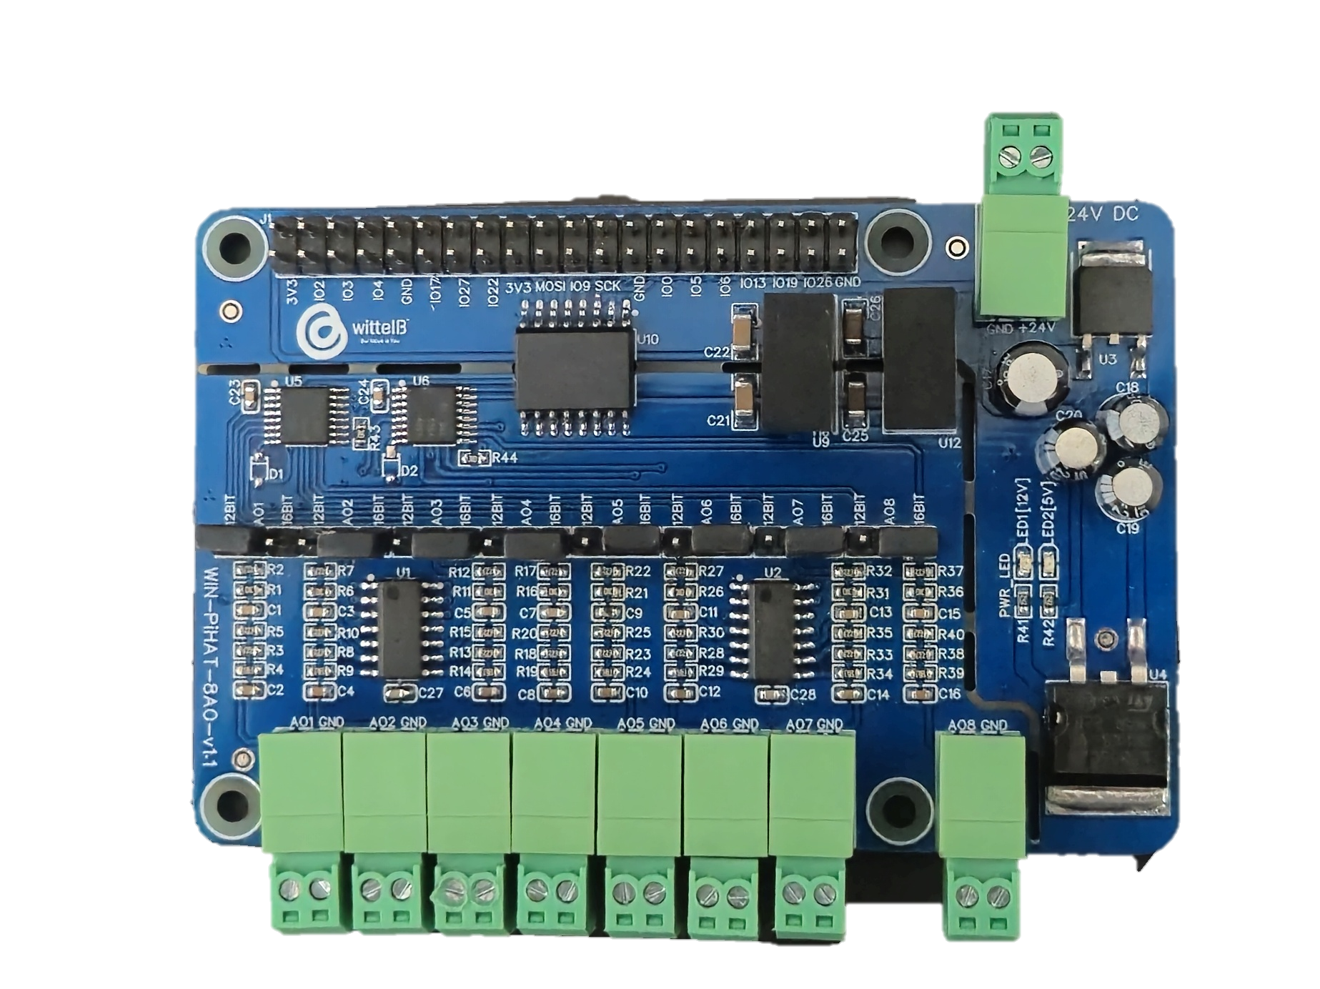
40 pin GPIO Headers
12/16 BIT JUMPER
12/24V DC SPLY
AO1 AO2 AO3 AO4 AO5 AO6 AO7 AO8
ANALOG OUTPUT
2
1
40
39
POWER LED

Contact us: -
Augmatic Technologies Pvt. Ltd.,
Plot no 6, Shah Industrial Estate II,
Kotambi,
Vadodara – 391510.
Email – Sales@wittelb.com
Support: support@wittelb.raiseaticket.com / +91 94038 92805

